To install python

Open [www.python.org](http://www.python.org)

Then go to downloads. Click on Download Python 3.7.3 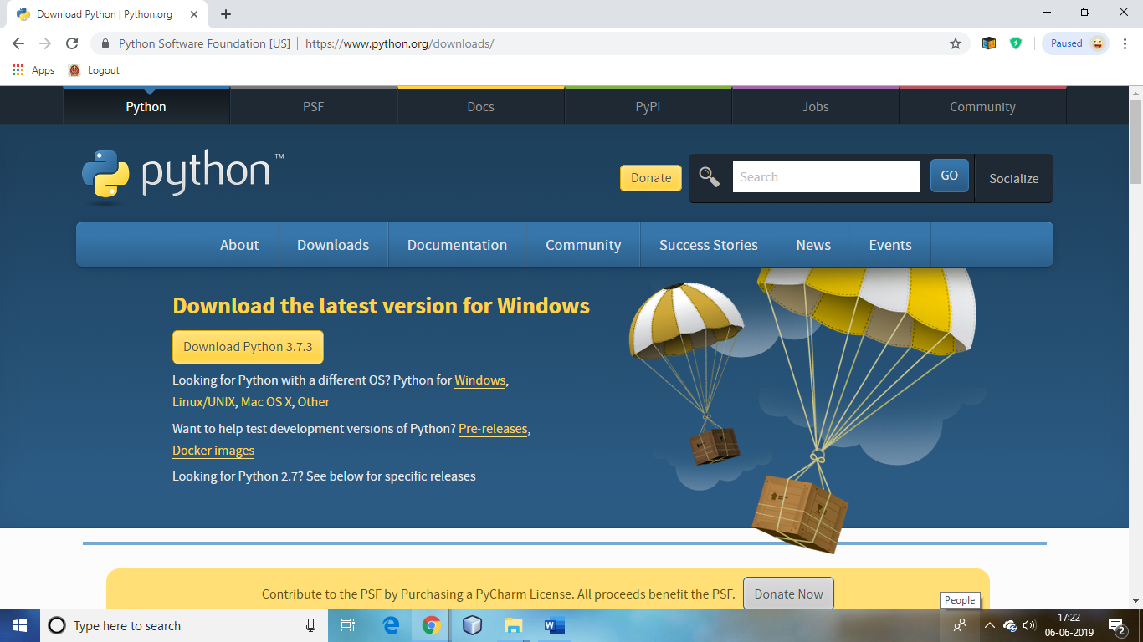

Make a folder in c drive with name “Python”

Open python installer

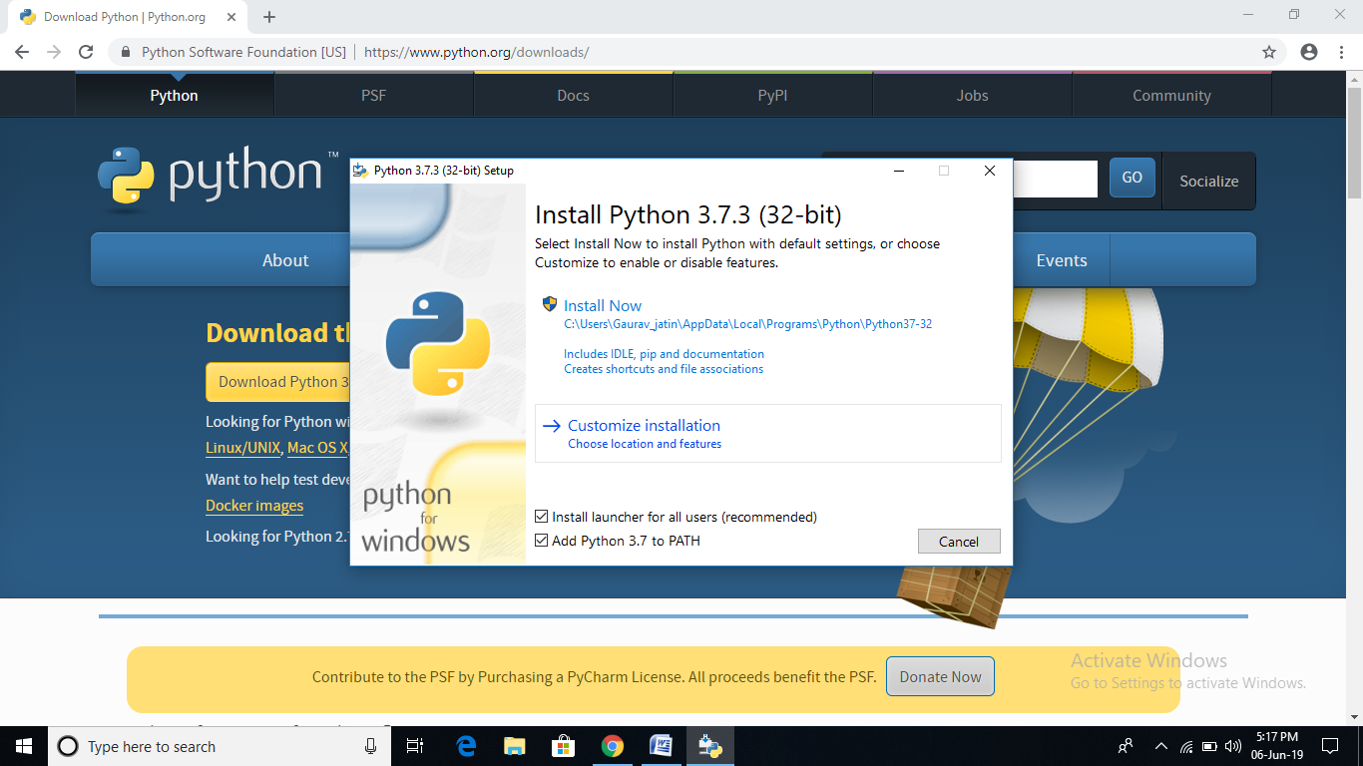

click on add python 3.7 to path

And add path

